**1011 Minor Project Lab Report**

Kiet Le

YouTube Video Link: <https://youtu.be/4V1vTJwvJ70>

**System Diagram:**

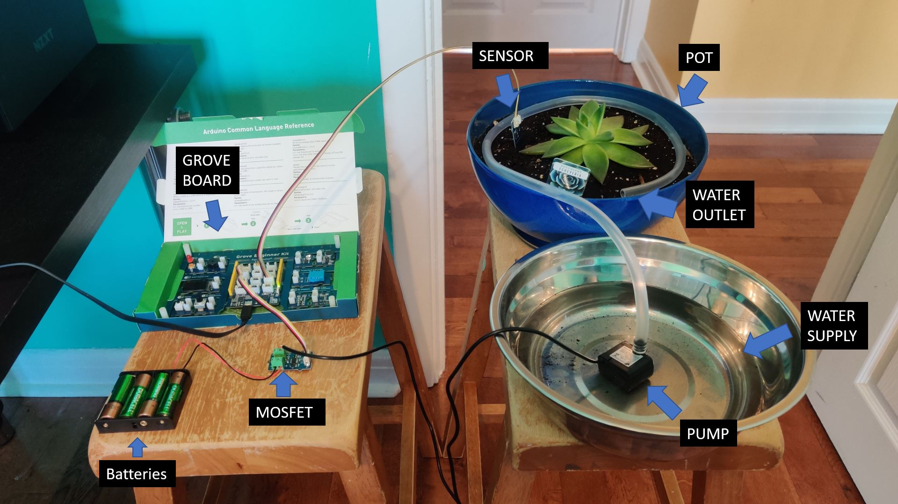

**Flowchart:**

